A DEEP LEARNING-BASED SWEET POTATO LEAF VARIETY DETECTION SYSTEM USING IMAGE PROCESSING

An Undergraduate Thesis

Presented to the Faculty of the
DEPARTMENT OF COMPUTER SCIENCE
College of Computer Studies
Borongan City State University
Borongan City, Borongan City

In Partial Fulfillment of the Course Requirement for the Degree
BACHELOR OF SCIENCE IN COMPUTER SCIENCE

Abrilla, Catherine B.
Noromor, Sianex Rose M.
Omega Jr., Kim E.

CHAPTER I
INTRODUCTION

Background and Rationale
Sweet potato (Ipomoea batatas) is an important root crop for food security and household income in the Philippines. This study focuses on two study varieties, yellow-fleshed sweet potato (YFSP) and white-fleshed sweet potato (WFSP), and on three leaf-image classification conditions: Healthy, Cercospora leaf spot, and sweet potato weevil infestation. Yellow and white refer to the flesh or storage-root color of the variety; they are variety labels, not condition labels. Studies show that sweet potato composition and quality vary by genotype and flesh color, which supports recording variety as part of the dataset rather than treating it as a disease class (Ji et al., 2015; Rosero et al., 2020).
Sweet potato health problems in Borongan City, commonly involve fungal leaf spotting and insect damage. These conditions can reduce plant vigor, marketable root yield, and the quality of planting material. Reliable field identification is therefore important, but visual inspection alone can be inconsistent when symptoms overlap, when lesions resemble ordinary weathering or nutrient stress, or when the leaf is not photographed clearly.
The three target conditions present observable features that can be represented in leaf images. Healthy plants generally show uniform, vigorous foliage without characteristic lesions. Cercospora leaf spot is associated with angular or irregular brown lesions that may have lighter centers and darker margins. Sweet potato weevil infestation is expressed on the foliage through the feeding punctures and small round holes that adult weevils leave on leaf blades and petioles, together with the yellowing, wilting, and loss of vigor that follow infestation of the vine below. Because this study is confined to leaf photographs, the weevil condition is recognized from these foliar indicators rather than from the storage-root and stem damage that would confirm an infestation directly.
Convolutional Neural Networks (CNNs) have demonstrated exceptional capability in image classification tasks, including the identification of plant disease symptoms from leaf photographs. CNNs learn hierarchical visual features: including color changes, lesion patterns, and textural irregularities: directly from image data without requiring manual feature extraction, enabling the automated detection and classification of disease symptoms that may be subtle or difficult for non-expert users to identify (Sharma et al., 2022). Transfer learning, a technique in which a CNN model is pre-trained on large general-purpose image datasets and subsequently fine-tuned on domain-specific data, has proven particularly effective in agricultural settings where labeled crop-specific datasets are limited (Pacal et al., 2024).
Despite the importance of sweet potato production, access to fast and affordable image-based screening remains limited for smallholder growers. A mobile classifier can provide preliminary screening, but it should not be presented as a laboratory diagnosis. Its usefulness depends on a balanced dataset, verified labels, representative images of both YFSP and WFSP, and a clear warning that low-confidence or unusual cases require confirmation by an agricultural technician.
The proposed system uses a CNN model based on MobileNetV2 and transfer learning. It classifies submitted leaf images into three conditions: Healthy, Cercospora leaf spot, and sweet potato weevil infestation. The application also records whether the image represents YFSP or WFSP, which keeps variety information separate from condition classification and allows model performance to be reported for each variety.
Despite this potential, sweet potato growers in Borongan City still lack access to reliable and affordable screening tools that do not depend on expert judgment, and delayed identification of plant health problems contributes to avoidable crop losses. Conventional visual inspection is inconsistent and subjective, and it depends on the availability of trained agricultural extension workers, who are often too few to serve the rural municipalities of the province. No publicly available mobile application or computational system is designed specifically for sweet potato health screening under Philippine field conditions, or for the yellow-fleshed and white-fleshed varieties commonly cultivated in Borongan City.
This study therefore seeks to develop and evaluate KamoTech, an offline-capable Android application that classifies sweet potato leaf images into the three target conditions using a MobileNetV2-based convolutional neural network. In pursuing this purpose, the study will examine which observable leaf characteristics distinguish healthy plants, Cercospora leaf spot, and sweet potato weevil infestation in YFSP and WFSP images and how those conditions can be learned from image data; how accurately the trained model classifies the three target conditions across both varieties; and how sweet potato farmers and agricultural students rate the usability of the resulting application when measured with the IBM Computer System Usability Questionnaire (CSUQ) developed by Lewis (1995).

Objectives of the Study
General Objective:
To develop a deep learning-based sweet potato leaf variety detection system using image processing, delivered as an offline-capable mobile application that classifies leaf images from yellow-fleshed and white-fleshed sweet potato plants into three target conditions (Healthy, Cercospora leaf spot, and sweet potato weevil infestation) while recording the variety of each submitted leaf, and to evaluate the resulting system using a standardized usability instrument.

Specific Objectives:
Specifically, the study aims to:
- Design and develop KamoTech, a user-friendly offline-capable Android mobile application enabling sweet potato farmers to capture or upload leaf images, indicate the variety (yellow-fleshed or white-fleshed), and obtain an automated condition detection result;
- Build and train a Convolutional Neural Network using MobileNetV2 transfer learning to classify leaf images into three conditions: Healthy, Cercospora leaf spot, and sweet potato weevil infestation, while recording yellow-fleshed and white-fleshed variety labels;
- Develop a condition-information module that provides the observable leaf symptoms, likely causal agent or pest, evidence-based management guidance, and limitations of leaf-based visual classification for each target condition;
- Evaluate the performance of the CNN model on the three target conditions using standard classification metrics, namely accuracy, precision, recall, F1-score, and a confusion matrix; and
- Assess the usability of the developed system using the original IBM Computer System Usability Questionnaire (CSUQ) of Lewis (1995), administered to sweet potato farmers and agricultural students in Borongan City.

Scope and Delimitation of the Study
This study focuses on the design, development, and evaluation of an Android mobile application for image-based classification of sweet potato leaf health and disease conditions. It covers three conditions: Healthy, Cercospora leaf spot, and sweet potato weevil infestation. It also covers two variety labels: yellow-fleshed sweet potato (YFSP) and white-fleshed sweet potato (WFSP).
- The system accepts digital photographs of sweet potato leaves captured through the device camera or selected from the gallery. Only leaf images are accepted; storage roots, stems, and soil are outside the scope of this study. The application can also detect when the submitted image is not a sweet potato leaf and prompt the user to retake or select another image.
- The system supports two study varieties: yellow-fleshed sweet potato (YFSP) and white-fleshed sweet potato (WFSP). Variety is recorded as a separate metadata label and is not treated as a disease. The variety label is selected by the user at the time of image submission; the CNN model classifies the leaf condition, and the recorded variety keeps the dataset and the reporting of model performance variety-aware.
- The system classifies submitted leaf images into three conditions: Healthy, Cercospora leaf spot, and sweet potato weevil infestation. For the weevil condition the system recognizes the foliar indicators of infestation, namely adult feeding punctures and holes on the leaf blade and petiole and the associated yellowing and wilting of the foliage.
- For each detected condition, the system displays the image, condition name, variety, a description of the causal agent or pest and its visual symptoms, peak seasonal occurrence, and recommended management actions.
- The mobile application is designed for Android smartphones running Android 8.0 (Oreo) or higher and functions without internet connectivity.
- System evaluation will use the original IBM Computer System Usability Questionnaire (CSUQ) of Lewis (1995), administered to sweet potato farmers and agricultural students in Borongan City.
The following delimitations apply to this study:
- The system detects only visible symptoms in submitted leaf images. It does not diagnose infections or pest damage that are not visually expressed on the leaf, and it does not replace laboratory or expert diagnosis. The system is likewise limited to images of sweet potato leaves; non-leaf or unrelated images fall outside its recognition scope and will not produce a valid classification result.
- The system is limited to the three defined conditions. Conditions outside this classification scope, including viral diseases, other fungal diseases, nutrient deficiencies, abiotic disorders, and unrelated insect pests, will not be recognized as valid target classes.
- The system does not diagnose nutrient deficiencies, abiotic disorders, or other diseases and pests outside the three target conditions. Visual similarities among Cercospora lesions, nutrient stress, and other causes of leaf discoloration may produce misclassification, so uncertain results require expert confirmation.
- Detection performance may be affected by image quality, lighting, background clutter, occlusion, leaf age, variety-related appearance, and mixed or simultaneous infections. The model is intended for single-label classification of the dominant visible condition in one submitted leaf image.
- The study is confined to leaf images. Storage roots, stems, and soil are outside its scope, and the system therefore cannot confirm a weevil infestation, assess below-ground damage, or evaluate soil condition. A weevil result indicates foliar signs consistent with infestation and should be followed by physical inspection of the vines and storage roots.
- The study is conducted as an undergraduate research project and is feasible within the resource and time constraints of the College of Computer Studies at Borongan City State University.

Limitations of the Study
The study is currently in the data-gathering stage, and the following limitation applies to the dataset and to the evaluation of the system. At present, the researchers do not yet have access to violet-fleshed and orange-fleshed sweet potato varieties for data collection. The dataset and the system evaluation will therefore be limited to the two available study varieties, yellow-fleshed sweet potato (YFSP) and white-fleshed sweet potato (WFSP), and violet-fleshed and orange-fleshed varieties will not be represented in the training data or in the beta-testing sample. As a result, the reported classification performance cannot be generalized to varieties whose leaf appearance differs from the varieties represented in the dataset, and the model may respond differently to leaf images from varieties it has not seen. Should violet-fleshed or orange-fleshed varieties become available during the study period, the researchers will coordinate with the research adviser on whether to extend the dataset; otherwise, the limited varietal coverage will be acknowledged in the interpretation of the results and in the recommendations of Chapter V.

Significance of the Study
Sweet Potato Farmers.
The KamoTech system provides sweet potato farmers in Borongan City with an on demand, accessible, and offline-capable tool for the early detection and identification of plant health and disease conditions. By enabling timely diagnosis without dependence on agricultural specialists, the system supports informed management decisions that can reduce crop losses, protect farm income, and improve overall crop health outcomes for farming households dependent on sweet potato cultivation.
Agricultural Extension Workers.
By providing automated first-level disease identification, the system reduces the volume of routine disease diagnosis requests received by agricultural extension workers, allowing them to redirect their expertise toward complex field-level agronomic advisory and community-level agricultural support services.

Agricultural Students.
The system serves as a practical, applied learning resource demonstrating the integration of artificial intelligence, image processing, and mobile application development in Philippine crop disease management: complementing theoretical coursework with a tangible and locally relevant technological tool.
Researchers.
This study contributes to the growing body of knowledge on AI-driven agricultural condition detection in the Philippine context. Its contribution is a locally focused leaf image dataset and mobile classifier for two sweet potato varieties and three target conditions, including an explicit account of what leaf-only screening can and cannot establish for an insect pest whose damage is largely concealed. The dataset, trained model, and evaluation framework can provide a foundation for future deep learning applications in Philippine root-crop agriculture.
Community and Local Agriculture.
By improving early condition detection and management outcomes in sweet potato cultivation, the system contributes to local food security, agricultural productivity, and the sustainable livelihood of farming communities in Borongan City and the broader Visayas region.

Target Classification Conditions and Scientific Justification
The following three classification conditions are proposed for KamoTech. They were selected because they represent one healthy reference class and two agriculturally meaningful disease or pest conditions with observable image features. The two varieties, YFSP and WFSP, are represented within each class whenever the condition is available in both varieties.

Table 1. Target Sweet Potato Classification Conditions for KamoTech
Class | Target condition | Causal agent or basis | Observable image features | Image basis
1 | Healthy | No target disease or pest detected | Uniform green foliage; no characteristic lesions, feeding holes, chlorosis, or wilting | Leaf
2 | Cercospora leaf spot | Cercospora species reported on sweet potato, including C. batatae in historical records | Angular or irregular brown to dark lesions, often with lighter centers or darker margins; possible defoliation | Leaf
3 | Sweet potato weevil infestation | Sweet potato weevil, Cylas formicarius and related Cylas spp. | Small round adult feeding punctures and holes on the leaf blade and petiole; yellowing, wilting, and loss of vigor in foliage above an infested vine. Foliar indicators only; stem and storage-root damage is not assessed | Leaf

Figure 1 below illustrates the seasonal occurrence pattern of each target condition across the Philippine calendar year, with emphasis on the Borongan City farming context. The chart guides farmers and researchers in understanding when disease and pest pressure is highest and when surveillance using KamoTech is most critical.
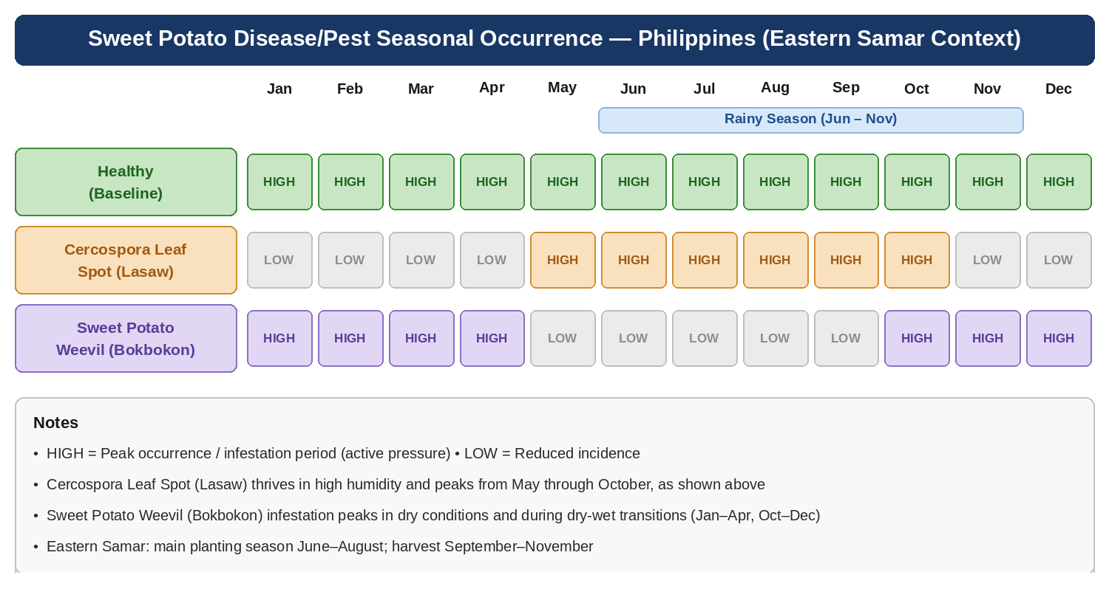
Figure 1. Seasonal Occurrence of the Target Sweet Potato Conditions in the Philippines (Borongan City Context)

CHAPTER II

REVIEW OF RELATED LITERATURE AND STUDIES

This chapter reviews literature and related studies that support the selection of the three target conditions and the two study varieties, as well as the use of deep learning for image-based agricultural classification. It is organized into: (1) the crop, varieties, and healthy reference class; (2) Cercospora leaf spot; (3) sweet potato weevil infestation; (4) CNNs and transfer learning; (5) dataset construction and augmentation; (6) mobile deployment; and (7) Philippine agricultural AI systems and the research gap. Within each theme the studies are presented chronologically, beginning with the foundational works that established each line of inquiry and proceeding through the 2019 to 2026 literature that defines current practice.

Review of Related Literature
Sweet potato varieties and the healthy reference class
Variety is an important source of visual and biological variation in image-based classification. Ji et al. (2015) compared sweet potato cultivars with different flesh colors, including yellow and white, and reported significant differences in nutrient composition among cultivars. Rosero et al. (2020) likewise found that genotype and flesh color were associated with differences in proximate composition and quality attributes. Sanchez et al. (2020) further reported significant variation among 19 Philippine sweet potato cultivars with white, yellow, and purple flesh. These studies support the inclusion of yellow-fleshed sweet potato and white-fleshed sweet potato as separate metadata groups in the dataset. They do not support treating flesh color as a disease class. Instead, the healthy class should contain representative images of both varieties so that the model learns normal variation rather than incorrectly interpreting variety-related appearance as a disease.
The healthy class is necessary as a reference class because a practical screening tool must distinguish plants that show no target condition from plants that show disease or pest symptoms. In a sweet potato image-classification study, Suhendar et al. (2023) included healthy leaves as one of the labeled classes, while Purnama et al. (2025) described uniform color and texture as characteristics of healthy leaves in an image-segmentation and classification workflow. These studies support retaining Healthy as a separate class and establishing clear labeling rules for normal tissue.
Cercospora leaf spot
Cercospora leaf spot is a fungal leaf condition characterized by visible lesions. Harter and Weimer (n.d.) documented Cercospora leaf spot of sweet potato and reported records from the Philippine Islands, describing dark-brown spots with lighter centers and lesions that may be limited by leaf veins. These features provide a reasonable visual basis for a Cercospora class, but the historical nature of the source means that current field labels should be verified by an agricultural specialist rather than assigned from appearance alone.
Broader sweet potato leafspot research also shows why lesion-based image classification is relevant. Ilondu (2013) assessed sweet potato leafspot damage across multiple farms and found that the percentage of damaged leaf area varied by location and was greatest on older leaves. The study did not establish that every observed lesion was Cercospora, so it should be used as supporting evidence for the importance of leafspot documentation, not as proof of the causal organism in Borongan City.
Sweet potato weevil infestation
Sweet potato weevil infestation is conventionally assessed through the stems and storage roots, because that is where the larvae of Cylas formicarius tunnel and where the resulting injury, discoloration, and loss of marketability are most evident. Reddy et al. (2014) evaluated entomopathogenic fungi and other treatments for sweet potato weevil management and emphasized the difficulty of controlling a pest whose larvae are concealed and whose adults are active at night. Akansake et al. (2018) subsequently quantified the relationship between weevil damage and nonmarketable storage-root yield, showing that greater damage was associated with greater yield loss. Rehman et al. (2019) found that organic mulches reduced weevil movement and storage-root damage, particularly during dry periods when soil cracking can facilitate pest access.
Because the present study is limited to leaf photographs, it targets the foliar expression of infestation rather than the concealed damage these studies measured. Adult weevils feed on the leaf blade and petiole, leaving small round punctures and holes, and foliage above an infested vine commonly yellows, wilts, and loses vigor. These foliar indicators are the visual basis for the weevil class in this study. The literature makes clear that such indicators are secondary rather than diagnostic: they may be absent in a light infestation and may resemble other causes of leaf injury. The application therefore presents a weevil result as a prompt to inspect the stems and storage roots, which the system itself does not examine, and a low-confidence result is reported as such rather than asserted.

Implications for the proposed classification system
The literature supports a three-class leaf classifier with Healthy as the reference class, Cercospora leaf spot as a fungal lesion class, and the foliar indicators of sweet potato weevil infestation as an insect-pest class. The conditions are not biologically equivalent, so the application should label its output as a target condition or status rather than implying that all three conditions are diseases of the leaf. The two varieties, YFSP and WFSP, should be balanced across the conditions where field material is available, and the weevil class in particular should be labeled only where an expert has confirmed infestation in the sampled plant, so that the model does not learn incidental leaf damage as a weevil signature.
Convolutional Neural Networks (CNNs) are a class of deep learning architectures specifically designed for image analysis tasks. CNNs learn hierarchical spatial feature representations by applying stacks of trainable convolutional filters across input images, enabling the extraction of progressively complex visual patterns: from edges and color gradients to disease-specific lesion shapes and textural anomalies: without requiring manual feature engineering (Sharma et al., 2022). This capacity makes CNNs the architecture of choice for plant disease detection from plant imagery.
Mohanty et al. (2020) provided an early benchmark demonstrating that CNN-based architectures reliably outperform traditional machine learning classifiers: including Support Vector Machines and Random Forests: across diverse agricultural image classification tasks. Their work established the foundational CNN pipeline for plant disease detection: image preprocessing, convolutional feature extraction, and fully connected classification layers. Waldamichael et al. (2022) confirmed this finding through a systematic review of machine learning methods applied to cereal crop disease detection, consistently identifying CNNs as superior in classification performance across 47 reviewed studies. Nyawose et al. (2025) extended this comparison to the most current architectures, confirming CNN dominance while identifying dataset imbalance: unequal representation of disease classes in training data: as a persistent accuracy-limiting challenge, directly informing the proposed system's balanced data collection strategy.
Sharma et al. (2022) evaluated multiple CNN architectures across different crop species, finding that deep models effectively capture fine-grained visual disease features including lesion morphology, chlorotic halos, and surface discoloration that cannot be reliably extracted by manual feature engineering or classical image processing. Their study cautioned, however, that models trained exclusively on controlled, laboratory-captured images frequently generalize poorly to field-captured imagery under variable lighting and background conditions: a methodological concern addressed in the proposed study through diverse field collection and augmentation of the sweet potato leaf training dataset. Upadhyay et al. (2025) corroborated these findings in a comprehensive 2025 review covering recent advances in plant disease detection, affirming CNNs as the dominant paradigm while advocating for realworld deployment readiness as an evaluation criterion alongside benchmark accuracy.
Transfer learning has emerged as the most impactful methodological innovation in agricultural image classification, addressing the fundamental challenge of training highperforming deep learning models in data-scarce crop-specific settings. The technique involves initializing a CNN with weights pre-trained on a large, general-purpose dataset: most commonly ImageNet: and fine-tuning the upper layers of the network on domain-specific agricultural imagery (Pacal et al., 2024). This strategy substantially reduces the number of labeled crop-specific training images required, shortens training time, and improves model generalization compared to training from scratch.
Cruz et al. (2018) established an early precedent by developing a lightweight transfer learning model for on-device plant disease classification, demonstrating that fine-tuned models can be compressed and deployed on consumer Android smartphones without significant performance degradation: a finding that directly informs the proposed system's MobileNetV2-based architecture and TensorFlow Lite deployment strategy. Narmadha et al. (2022) later demonstrated the power of transfer learning for crop disease classification by combining a pre-trained DenseNet169 base with a Multilayer Perceptron classifier for rice disease detection, achieving 97.68% accuracy on their experimental dataset. Their results confirmed that pretrained convolutional feature extractors generalize effectively to plant disease imagery even without domain-specific pretraining.
Pacal et al. (2024) published the most comprehensive review of transfer learning in crop disease detection to date, covering 162 studies from 2018 to 2024 and identifying transfer learning on lightweight architectures (MobileNet, EfficientNet, ShuffleNet) as the dominant direction for mobile-deployable agricultural AI. Their review specifically noted that DenseNet and ResNet architectures, while achieving higher laboratory accuracy, are frequently impractical for on-device mobile deployment due to parameter and memory constraints. Ma et al. (2024) further demonstrated that feature-level transfer using mid-layer CNN representations improves disease discrimination under real-world imaging variability, providing a technical rationale for the feature extraction strategy adopted in the proposed KamoTech model.
A persistent and widely acknowledged limitation in plant disease detection research is the scarcity of large, balanced, crop-specific labeled image datasets for locally significant crops. Most benchmark datasets, including the widely used PlantVillage dataset, cover a limited range of commercial crops under controlled laboratory conditions and do not include sweet potato or other root crops widely grown in developing Southeast Asian agricultural economies (Waldamichael et al., 2022; Pacal et al., 2024). The absence of a dataset tailored to Borongan City, the two study varieties, and the three target conditions necessitates the construction of a custom training dataset for the proposed study.
Data augmentation has become the standard and most effective strategy for artificially expanding limited training datasets while simultaneously improving model robustness to realworld imaging variability. Research consistently demonstrates that augmentation techniques: including random horizontal and vertical flipping, rotation, brightness and contrast adjustment, zoom, and color jitter: improve CNN generalization performance when applied during training (Sharma et al., 2022; Narmadha et al., 2022). The FAO (2023) reinforced the urgency of building locally calibrated agricultural datasets, reporting that annual crop disease yield losses of 20 to 40 percent are concentrated in developing economies where specialty food crops such as sweet potato are primary income sources for smallholder farming communities. Nyawose et al. (2025) specifically recommended stratified augmentation: applying targeted augmentation to underrepresented disease classes: as the most effective strategy for mitigating class imbalance in small custom crop disease datasets.
The practical utility of deep learning agricultural systems is fundamentally determined by their accessibility to the farming communities they are designed to serve. Cruz et al. (2018) established an important early benchmark by developing a lightweight neural network model specifically designed for on-device plant disease detection on consumer Android smartphones, demonstrating that TensorFlow Lite model compression enables reliable realtime CNN inference within the memory and processing constraints of mid-range mobile devices. Their work confirmed the viability of offline, server-free mobile deployment: a design principle central to KamoTech's development, given the limited internet connectivity of target farming communities in Borongan City.
Lagmay (2024) provided direct empirical evidence of these adoption dynamics in a Philippine agricultural context, finding that Filipino farmers demonstrated strong willingness to adopt AI-based disease diagnostic tools provided these were designed to be intuitive, practically actionable, and independent of internet connectivity. Upadhyay et al. (2025) then reviewed real-world deployment considerations for deep learning plant disease systems more broadly, identifying offline capability, low hardware requirements, plain-language output presentation, and intuitive user interfaces as the critical design factors determining farmer adoption. These findings directly shaped the design philosophy and user experience of the KamoTech mobile application.
The Philippine agricultural AI research landscape has grown considerably since 2019, with an increasing number of studies demonstrating the feasibility and practical value of CNNbased disease detection for locally significant crops. Mique and Palaoag (2018) established a foundational precedent with a CNN-based rice pest and disease detection application that delivered classification results alongside disease-specific management guidance: a coupled detection-and-guidance design principle that the proposed KamoTech system adopts and extends to sweet potato foliar diseases.
Dioses et al. (2024) advanced the state of Philippine agricultural AI by developing a ResNet50-based system for rice plant disease detection using locally sourced Philippine field imagery, achieving strong classification accuracy while demonstrating that deep CNN architectures can be effectively adapted to Philippine crop photography conditions. IJACSA (2024) reported comparable results for cacao disease detection in the Philippines, confirming image-based CNN classification as reliable for diverse Philippine tropical crop disease types. Lagmay (2024) complemented these technical advances with a farmer-focused study establishing that technology adoption readiness among Philippine smallholder farmers is high provided design standards for usability and practicality are met.
Critically, none of the reviewed Philippine agricultural AI studies addresses sweet potato: a crop of substantial economic and food security importance across Eastern Visayas and Borongan City specifically. This gap represents both a deficiency in the existing research landscape and a concrete opportunity for novel, locally relevant contribution. The proposed KamoTech system directly addresses this gap by developing a locally focused CNN-based sweet potato health and disease detection system trained on Borongan City sweet potato imagery, targeting the two varieties most commonly cultivated in the region and covering the two disease or pest conditions and one healthy reference class documented in Philippine sweet potato agriculture.

Review of Related Systems
The following reviews eight published systems with objectives comparable to the proposed KamoTech study, presented in chronological order, examining their methodologies, performance outcomes, and limitations to contextualize the proposed system's design choices and contributions.
Cruz et al. (2018) demonstrated on-device CNN deployment for plant disease detection using a lightweight mobile-optimized architecture. Their TensorFlow Lite deployment approach is directly adopted by KamoTech, with the extension of covering sweet potato specifically with a three-class classification scheme and an integrated guidance module.
Mique and Palaoag (2018) developed a CNN rice pest and conditions detection application that coupled classification with management guidance: the design paradigm adopted in KamoTech's condition-information module, extended to cover three sweet potato diseases with seasonal occurrence data.
Mohanty et al. (2020) established the standard CNN disease detection pipeline benchmarked across multiple crop species but did not address mobile deployment, real-field image variability, or end-user guidance. KamoTech extends this foundational work with mobile-first design, offline capability, and an integrated condition-information module.
Narmadha et al. (2022) developed a transfer learning model combining DenseNet169 with a Multilayer Perceptron for rice disease detection, achieving 97.68% accuracy through a multi-stage pipeline including Fuzzy C-Means segmentation. The architecture's computational complexity limits mobile deployment: directly informing KamoTech's adoption of the lighter MobileNetV2 backbone optimized for Android on-device inference.
Sharma et al. (2022) evaluated multiple CNN architectures for plant disease diagnosis, confirming CNN superiority while documenting poor generalization under variable field conditions. This finding motivated KamoTech's diverse field data collection and aggressive augmentation pipeline to improve robustness to real-world imaging conditions in Borongan City farms.
Waldamichael et al. (2022) systematically reviewed crop disease detection methods, conclusively identifying CNNs and transfer learning as superior approaches. Their identification of dataset scarcity and real-world deployment gaps as critical unresolved issues directly motivates KamoTech's field-collection dataset strategy and offline architecture.
Lagmay (2024) studied Satsuma citrus disease detection alongside Filipino farmer technology adoption readiness, finding strong adoption willingness contingent on intuitive design and practical guidance. These findings directly shaped KamoTech's plain-language interface design, management recommendation module, and offline-first deployment strategy.
Dioses et al. (2024) achieved high accuracy in Philippine rice disease detection using ResNet50 on locally sourced field imagery, validating that deep CNN transfer learning is effective for Philippine agricultural data. KamoTech extends this approach to sweet potato, a crop that remains underrepresented in localized Philippine agricultural AI systems, delivering results in a farmer-accessible mobile application rather than a laboratory prototype.

Synthesis
The reviewed literature supports CNN-based image classification and transfer learning for agricultural image analysis, but it also shows that model validity depends on representative data and correct labels. For this study, representative data means leaf images from both yellow-fleshed and white-fleshed sweet potato varieties and balanced representation of the three target conditions. The literature on Cercospora leaf spot and sweet potato weevil infestation also indicates that visual symptoms can overlap, and that weevil infestation is only indirectly expressed on the foliage, so the application should communicate that its output is a preliminary screening result.
Against this background, a research gap remains in a localized, mobile, leaf-image based system that jointly records sweet potato variety and condition while covering Cercospora leaf spot and the foliar indicators of sweet potato weevil infestation. The proposed KamoTech system addresses this gap through a three-class classifier, a dataset organized by YFSP and WFSP, expert-supported labeling, and offline mobile deployment. The system is not presented as a substitute for laboratory or field confirmation by a plant-health specialist, and it does not assess storage roots, stems, or soil.
CHAPTER III

METHODOLOGY

This chapter presents the proposed methodology for developing KamoTech: a deep learning-based sweet potato leaf variety detection system using image processing. It covers the software development model, requirement analysis, system design, dataset construction, CNN training, evaluation, and implementation plan. The methodology is aligned with three target conditions and two study varieties, and with a dataset composed exclusively of leaf images.

Software Development Model
The Agile Software Development Model is an iterative and incremental methodology that organizes development into short, time-boxed cycles called sprints, each producing a functional and testable system component (Beck et al., 2001). Agile was selected for this study because it accommodates evolving requirements, supports continuous model performance feedback integration, and enables progressive refinement of both the CNN classifier and the KamoTech mobile application across three primary phases: planning and requirement analysis, design, development, and evaluation.

Requirement Analysis
Requirement analysis is the systematic process of identifying, documenting, and validating the functional and non-functional specifications necessary for successful software system development (Sommerville, 2016). For this study, requirements will be determined through a review of related literature on sweet potato disease detection, consultation with the thesis adviser and an agricultural extension specialist, and an assessment of the target user environment in Borongan City.

Technical Requirements
Table 2 presents the hardware and software specifications required for the development and deployment of the KamoTech system.

Table 2. Technical Requirements of the KamoTech System
Component | Specification
Development Machine | Laptop or desktop PC with minimum 8 GB RAM, Intel Core i5 or equivalent processor, at least 50 GB available storage
GPU (Recommended) | NVIDIA GPU with CUDA support for accelerated CNN model training; Google Colab Pro as cloud alternative
Operating System | Windows 10/11 (development); Android 8.0 or higher  (deployment)
Programming Languages | Python 3.9 or higher (model development); Dart/Flutter  (mobile application)
Deep Learning Framework | TensorFlow 2.x / Keras for CNN model design, training, and evaluation
Mobile Development IDE | Visual Studio Code with Flutter SDK; Android Studio for emulator setup
Dataset | Custom sweet potato plant image dataset collected from local Borongan City farms and augmented; MobileNetV2  ImageNet pretrained weights for transfer learning
Target Deployment Device | Android smartphone running Android 8.0 (Oreo) or higher; standard consumer-grade hardware

Operational Requirements
Operational requirements define the expected runtime behavior and performance standards of the system from the end user's perspective (Sommerville, 2016). The KamoTech system will meet the following operational requirements:
- Users can submit a sweet potato plant image by capturing a photograph using the smartphone camera or selecting an image file from the device gallery.
- The system will accept leaf images of both yellow-fleshed sweet potato (YFSP) and white-fleshed sweet potato (WFSP), with the variety recorded as a metadata label.
- The system will return a classified condition result with a confidence score within five seconds under normal device operating conditions.
- Each detection result will include the target condition, confidence score, recorded variety, observable leaf symptom description, likely causal agent or pest, evidence-based management guidance, and a warning to seek expert confirmation for low-confidence or unusual cases.
- The application will function entirely without internet connectivity on standard consumer-grade Android smartphones.
- The application interface will be designed for usability by non-expert users with limited digital literacy, using plain language and intuitive navigation throughout.

Gantt Chart
Table 3 presents the proposed schedule of development activities across a ten-week period.

Table 3. Gantt Chart of Development Activities
Activity | M1 | M2 | M3 | M4 | M5 | M6 | M7 | M8
Requirement Analysis &  Planning | ✓
Field Data Collection  (Sweet Potato Plant Images) | ✓
Dataset Preprocessing &  Augmentation | ✓ | ✓
CNN Model Design &  Transfer Learning |  | ✓ | ✓
Model Training, Testing &  Optimization |  |  | ✓ | ✓
Mobile App UI/UX Design  & Prototyping |  |  | ✓ | ✓
System Integration &  Development |  |  |  | ✓ | ✓
Unit & Integration Testing |  |  |  |  | ✓ | ✓
Acceptance Testing / Beta  Testing (CSUQ) |  |  |  |  |  |  | ✓
Documentation & Final  Writing |  |  |  |  |  |  |  | ✓

Design
The design phase translates identified requirements into concrete specifications for the user interface, system processes, data structures, and overall system architecture. Design in software engineering is the process of defining the architecture, components, interfaces, and other system characteristics to satisfy specified requirements (ISO/IEC 25010, 2011).

Conceptual Framework
The conceptual framework of KamoTech integrates three primary components: Input, Process, and Output. The Input component consists of a sweet potato leaf image submitted by the user together with the selected variety label (YFSP or WFSP). The Process component encompasses image quality checking, resizing and normalization, CNN feature extraction, three-class classification via the fine-tuned MobileNetV2 TFLite model, and retrieval of condition information from the embedded JSON data map. The Output component delivers the predicted condition, confidence score, variety, observable symptom description, management guidance, and a notice that the result is preliminary and based on leaf appearance alone. The system is designed for offline operation.

Output and User Interface Design
User Interface (UI) design is the process of creating visual layouts and interactive elements through which users interact with a software system, with the goal of maximizing usability and accessibility for the intended user population (Nielsen, 1994). The KamoTech mobile application is designed with simplicity and accessibility as primary design considerations, ensuring full usability by sweet potato farmers with limited technical background.
The application consists of three main screens. The image submission screen includes a variety selector and capture guidance that keeps a single leaf framed and in focus, since leaf appearance is the only evidence the classifier receives.
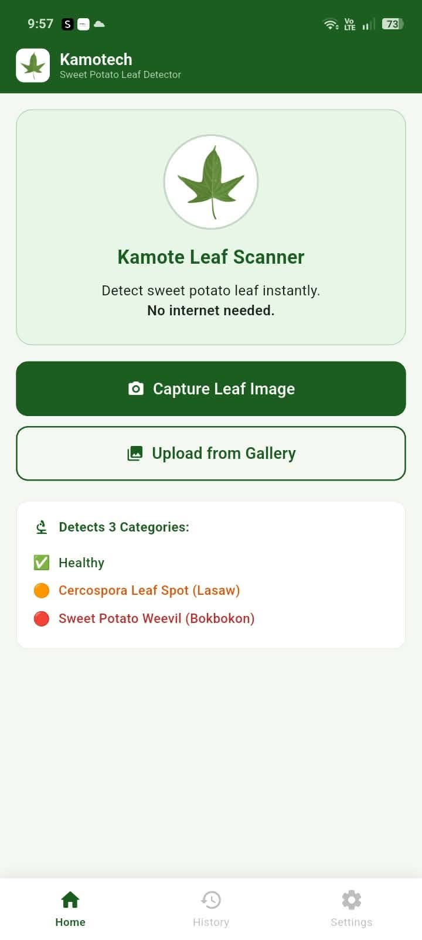
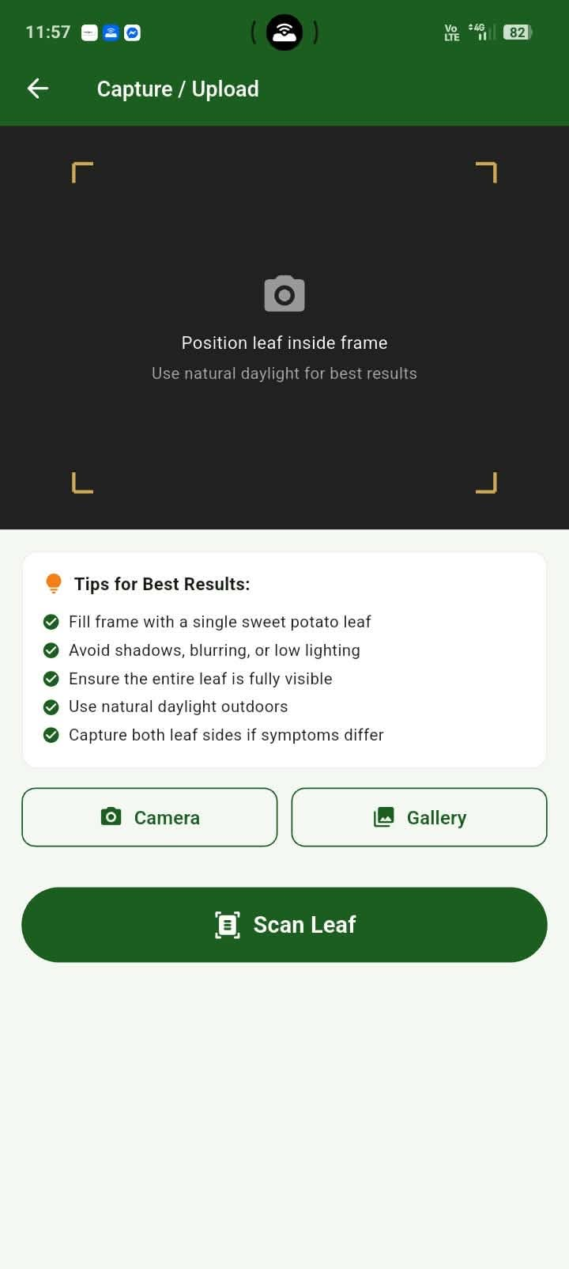

Figure 2. Home Screen Figure 3. Image Capture / Upload Screen

Figure 2: Home Screen. The application entry point displays the KamoTech logo, a brief description of the system, two primary action buttons for capturing or uploading a leaf image, and a summary of the three target conditions: Healthy, Cercospora leaf spot, and sweet potato weevil infestation. The screen uses high-contrast green styling consistent with the agricultural theme.

Figure 3: Image Capture/Upload Screen. The screen provides a camera viewfinder with a leaf-alignment guide and a variety selector for yellow-fleshed or white-fleshed sweet potato. Capture tips guide users toward clear, well-lit images of a single leaf. A preview panel displays the selected image before submission, and a Scan Leaf button triggers CNN inference.

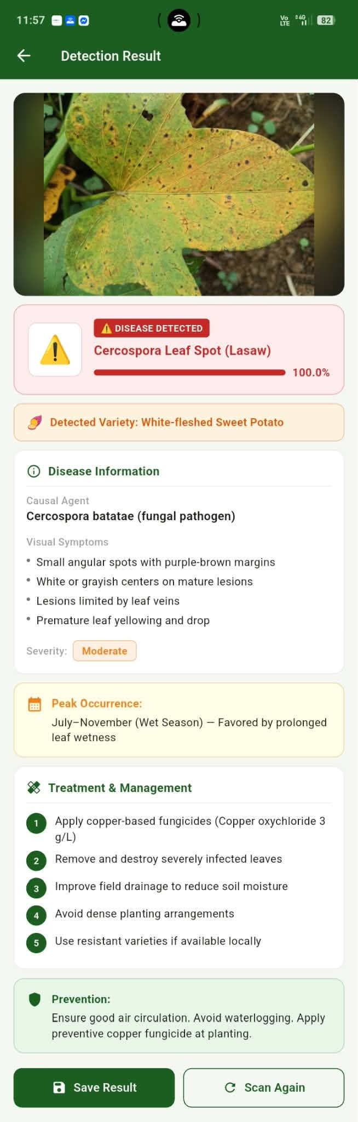
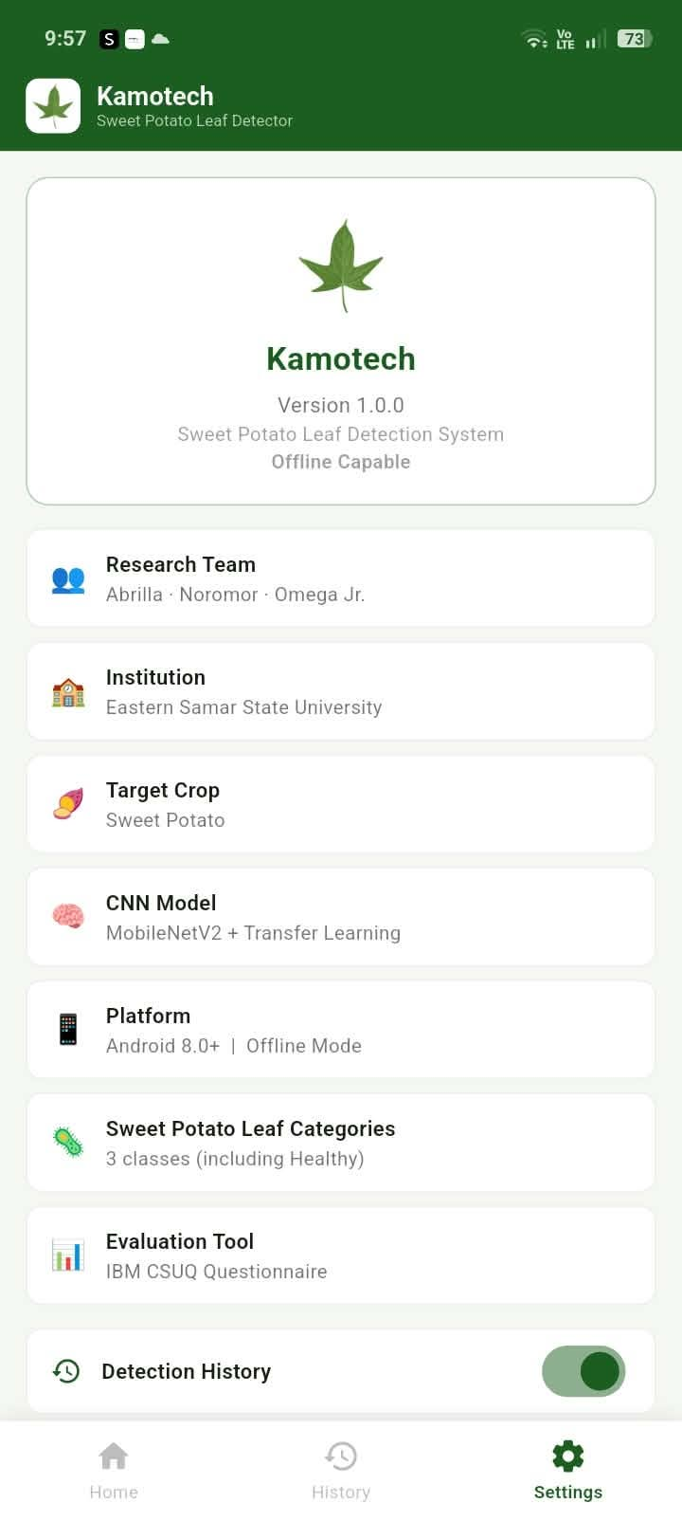

Figure 4. Detection Result Screen Figure 5. Settings Screen

Figure 4: Detection Result Screen. The screen displays the predicted target condition or Healthy status, confidence score, recorded variety, observable leaf symptoms, likely causal agent or pest, management guidance, and a notice that the result is preliminary and may require expert confirmation. Save Result and Scan Again buttons are provided.
Figure 5: Settings Screen: Displays application metadata including version number, research team members, institution, target crop varieties, and CNN model used. Users can toggle detection history logging and the seasonal condition display feature on or off. A button is provided to clear stored detection history. A consistent bottom navigation bar appears across all screens.

Process Design
Process design specifies the logical workflows and data transformations that govern system behavior, represented through Data Flow Diagrams and a system flowchart (DeMarco, 1979).

Data Flow Diagram: Level 0 (Context Diagram)
The Level 0 DFD in Figure 6 illustrates the highest-level view of KamoTech as a single process. The system receives a sweet potato leaf image and a variety label from the farmer and returns a target-condition classification result comprising the condition, confidence score, symptoms, management guidance, and diagnostic limitation notice. The system queries the internal Condition Info Store to retrieve information corresponding to the classification output.

Categories Name. Variety, Symptom, Peak Occurrence, Treatment.& Management and Prevention
Level 0 | KamoTech KAMOTECH CONDITION DETECTION SYSTEM SWEET POTATO FARMER D1: Condition Info Store (JSON Map) Sweet Potato Leaf Image JPEG/PNG Condition Name, Variety, Symptoms, Peak Occurrence, Treatment & Management, Prevention Query Class ID Condition Record Embedded in app)( NOTATION KEY: External Entity Process Data Store Data Flow Level 0 | KamoTech KAMOTECH CONDITION DETECTION SYSTEM SWEET POTATO FARMER D1: Condition Info Store (JSON Map) Sweet Potato Leaf Image JPEG/PNG Condition Name, Variety, Symptoms, Peak Occurrence, Treatment & Management, Prevention Query Class ID Condition Record Embedded in app)( NOTATION KEY: External Entity Process Data Store Data Flow

KAMOTECH CATEGORIES DETECTION SYSTEM

SWEET POTATO FARMER/STUDENT

D1: Variety/Categories Info Store (JSON Map)

Sweet Potato Leaf Image JPEG/PNG

Query Class ID

Variety/Categories Record

External Entity

Process
Data Store

Data Flow

Figure 6. Data Flow Diagram – Level 0 (Context Diagram)

Data Flow Diagram: Level 1 (Decomposed Processes)
The Level 1 DFD in Figure 7 decomposes KamoTech into four sub-processes. P1 (Image Input and Preprocessing) receives the raw leaf image and variety label from the farmer and applies resizing and normalization. P2 (Feature Extraction via CNN) processes the preprocessed input through the embedded MobileNetV2 convolutional layers, producing a feature vector. P3 (Target-Condition Classification) applies the three-class Softmax output layer and queries the Condition Info Store for the matched record. P4 (Result Generation and Display) assembles and renders the complete result to the user. All detection events are recorded to the on-device Detection Log.

Level 1 | KamoTech

SWEET
POTATO
FARMER

P1: Image
Input &
Preprocessi
ng

P2: Feature
Ext
raction
)
CNN
(

P3: Categories
Classificatio
n

P4: Result +
Generation
& Display

SWEET
POTATO
FARMER

D1: Categories Info
Store (JSON
Map)

D2: Detection Log (On
-
Device)

Leaf Image

Pre processed
× 224 px
224

Feature Vector

Query Class

Categories info +
Season Record

Categories Class +
Confidence
Score

Result +
Treatment

Log Entry: Class,
Confidence,
Figure 7. Data Flow Diagram – Level 1 (Decomposed Processes)

System Flowchart
The system flowchart in Figure 8 traces the complete operational logic of KamoTech, from application launch through leaf image selection, variety identification, preprocessing, CNN inference, confidence evaluation, condition-information retrieval, and result display. If no image is selected, the system loops back to image selection. If the confidence score falls below the predefined threshold, the system prompts the user to retake the image under better lighting or framing conditions. Upon successful classification, the system displays the result and optionally logs the detection event on the device.

Start

User Opens KamoTech App

Select Capture Camera

or Upload
from Gallery

Image
Selected/Captur
ed?

Color Variety: White or Yellow

Display Image Preview

Pre processed Image: Resize 224 x
px Normalize
224

No

Yes

System Flowchart | KamoTech

CNN Inference (MobileNetV2 TFLite)
On
-
Device Offline

Confidence >
Threshold?

Retrieve Condition Info from JSON
Data Map

Display Result Screen: Condition Name, Variety, Information, Peak Occurrence, Treatment and Management, Prevention
Save Result?

END

Prompt
Retake/Clearer
Image

No

Yes

Save to
Detection Log

Yes

No/Done

Figure 8. System Flowchart – KamoTech Detection Process

System Architecture
System architecture refers to the high-level structure of a software system, defining major components, their responsibilities, and how they interact with one another (Bass et al., 2012). As illustrated in Figure 9, KamoTech follows a three-tier client-side architecture designed for fully offline Android mobile deployment.

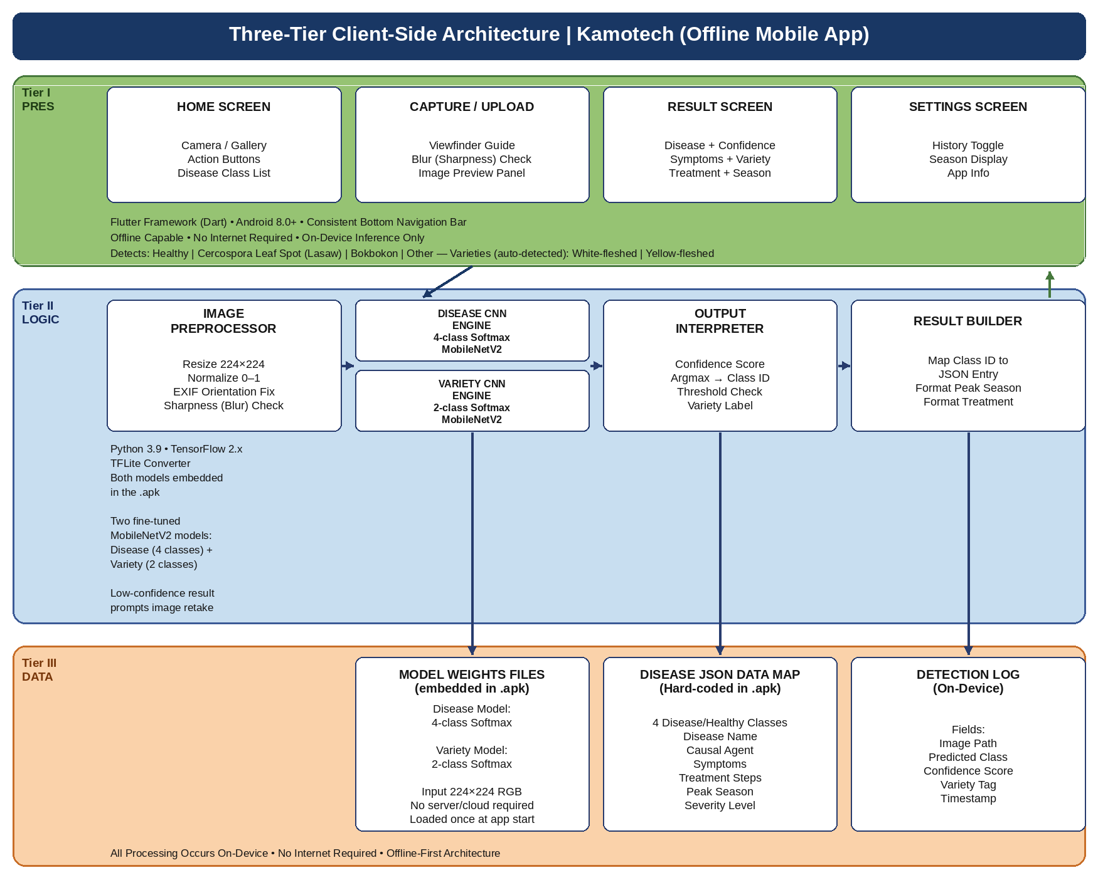
Figure 9. Three-Tier Client-Side System Architecture – KamoTech

The Presentation Layer (Tier 1) consists of the Flutter-based mobile application frontend developed in Dart, encompassing the application screens and the consistent bottom navigation bar. User interactions, including leaf image capture, gallery selection, variety selection, and result display, are handled at this tier.
The Application Logic Layer (Tier 2) manages image preprocessing, passes the preprocessed image tensor and metadata to the CNN inference engine, interprets the Softmax output to determine the target condition and confidence score, applies the confidence-threshold check, and invokes the result builder to retrieve and format the appropriate condition information. The CNN model is embedded as a TensorFlow Lite file within the application package, enabling fully offline inference.
The Data Layer (Tier 3) consists of three components: the Condition JSON Data Map containing the three target conditions, causal agents or pest, observable leaf symptoms, and management recommendations; the on-device Detection Log; and the Model Weights File containing the fine-tuned MobileNetV2 weights. No external server, cloud service, or relational database is required.

Development

Dataset Description and Collection
The training dataset will be constructed through systematic field collection of sweet potato leaf images from farming communities in Borongan City, supplemented only by open or partner images whose labels and usage permissions can be verified. Images will be collected from both YFSP and WFSP plants and will consist exclusively of leaf photographs. Healthy images will establish normal visual variation, Cercospora images will focus on leaf lesions, and weevil images will focus on the feeding punctures, perforations, and associated chlorosis visible on the leaves of confirmed infested plants. This structure follows the literature showing variety-related visual variation and lesion-based leafspot assessment, while accounting for the indirect foliar expression of weevil infestation (Ji et al., 2015; Harter & Weimer, n.d.; Rehman et al., 2019).
Table 4. Proposed Variety-Aware Leaf Image Dataset Composition for KamoTech
Class | Target condition | YFSP raw target | WFSP raw target | Total raw | After augmentation
1 | Healthy | 200 | 300 | 500 | 1,000+
2 | Cercospora leaf spot | 250 | 250 | 500 | 1,000+
3 | Sweet potato weevil infestation | 200 | 300 | 500 | 1,000+
 | TOTAL | 650 | 850 | 1500 | 3,000+

All collected images will undergo quality screening to exclude blurred, obstructed, duplicated, mislabeled, or non-leaf images before annotation. Each record will include the variety, target condition, collection location, date, and source. Disease and pest labels will be reviewed by an agricultural extension specialist or plant-health expert. Cercospora labels will be verified from lesion evidence and expert review. Weevil labels present a particular labeling risk, because the confirming evidence lies in the stem and storage root rather than the leaf; a leaf image will therefore be assigned to the weevil class only when the specialist has confirmed infestation in the sampled plant, so that incidental leaf injury is not learned as a weevil signature (Harter & Weimer, n.d.; Akansake et al., 2018).

Image Preprocessing and Augmentation
All submitted images will undergo the following preprocessing steps before model training: resizing to 224 × 224 pixels to match MobileNetV2 input dimensions, pixel-value normalization to the range 0 to 1 by dividing by 255, and image-quality filtering. The preprocessing pipeline will keep the whole leaf in frame and will avoid cropping away lesions or feeding holes near the leaf margin. Data augmentation will be applied exclusively to the training subset using horizontal flipping where biologically appropriate, small rotations, brightness and contrast adjustment, zoom, and limited noise injection. Augmentation will not be used to create labels that are not supported by field evidence.

CNN Model Architecture and Training
The CNN model for KamoTech will be built using MobileNetV2 pretrained on ImageNet as the base feature extractor. The classification head will consist of Global Average Pooling, Batch Normalization, a Dense layer with 256 ReLU units, Dropout for regularization, and a final Dense output layer with 3 units and Softmax activation, one for each target condition.
Training will proceed in two phases. In Phase 1, the MobileNetV2 base weights will be frozen while the classification head is trained. In Phase 2, the upper layers will be fine-tuned with a reduced learning rate, early stopping, and model checkpointing. The final model will be evaluated separately by target condition and by variety so that strong overall accuracy does not conceal poor performance on YFSP, WFSP, or the weevil class.

Programming Environment
Table 5. Programming Environment for KamoTech
Tool / Environment | Purpose
Python 3.9 | CNN model development, training, evaluation, and  TFLite conversion
TensorFlow 2.x / Keras | Deep learning framework for model architecture, training, and callbacks
MobileNetV2 (ImageNet weights) | Pre-trained base model for transfer learning
TensorFlow Lite Converter | Converts trained Keras model to. tflite format for mobile deployment
Google Colaboratory (Pro) | Cloud GPU environment for model training and experiment tracking
Visual Studio Code + Flutter SDK | Primary IDE for mobile application development
Dart Programming Language | Mobile application logic and UI implementation
Android Studio | Android emulator configuration and application testing
Custom Sweet Potato Plant Dataset | Primary training data: 3 conditions, collected from Borongan City farms
GitHub | Version control, source code management, and collaborative development
Google Colab | Train Images

Evaluation

Research Design
A developmental research design is employed, appropriate for studies involving the systematic creation, implementation, and empirical evaluation of a technology product (Richey & Klein, 2007). A descriptive-evaluative approach is applied during the evaluation phase, wherein target respondents assess the system through structured hands-on interaction. Quantitative data will be collected through the original IBM Computer System Usability Questionnaire (CSUQ), supplemented by open-ended qualitative observations.

Locale
The study will be conducted at Borongan City State University, Borongan City, Borongan City, Philippines. Beta testing and usability evaluation sessions will be held on university premises. Respondents will be drawn from the local sweet potato farming community and from agriculture-related students enrolled at the university.

Respondents
The study will involve two purposively selected respondent groups: twenty (20) sweet potato farmers from farming communities in Borongan City and adjacent municipalities of Borongan City, and twenty (20) agricultural students enrolled at Borongan City State University, for a total of forty (40) respondents. This sample size is consistent with comparable developmental research studies in the field and sufficient for descriptive statistical analysis of CSUQ responses.

Instrumentation
Usability Questionnaire (IBM CSUQ).
The IBM Computer System Usability Questionnaire (CSUQ), developed by Lewis (1995), is a 19-item standardized instrument for assessing user satisfaction with computer systems. Each item is rated on a seven-point scale (1 = Strongly Disagree to 7 = Strongly Agree), and a Not Applicable (NA) option is provided for items a respondent cannot answer. The CSUQ yields an overall score and three subscales: System Usefulness (SYSUSE), Information Quality (INFOQUAL), and Interface Quality (INTERQUAL). Lewis (1995) reported coefficient alphas of .93 for SYSUSE, .91 for INFOQUAL, .89 for INTERQUAL, and .95 for the overall scale. The CSUQ was selected for this study because it is a standardized instrument with established psychometric properties, and because its three subscales support a diagnostic analysis of usability. The 19 official items will be administered verbatim; the supplementary respondent-information and open-ended questions in the appendix are not part of the official instrument.
Model Performance Metrics.
The CNN model's technical performance will be evaluated on the held-out test set using accuracy, precision, recall, F1-score, and a confusion matrix across the three target conditions. Additional summaries will report performance by variety (YFSP and WFSP). These analyses are necessary because a model could achieve acceptable overall performance while failing on one variety or on the weevil class, whose foliar indicators are the least distinctive of the three.

Data Analysis
CSUQ responses will be analyzed using descriptive statistics. For each subscale, the subscale score will be computed as the mean of the responses to the items belonging to that subscale, and the overall score as the mean of the responses to all 19 items; NA responses will be excluded from these computations, following the administration and scoring instructions of Lewis (1995). Results will be reported as means and standard deviations for the three CSUQ subscales (SYSUSE, INFOQUAL, INTERQUAL) and for the overall CSUQ score, and will be described using the interpretation scale in Table 6.

Table 6. Interpretation Scale for Seven-Point CSUQ Responses
Scale Range | Descriptive Rating | Interpretation
6.51 - 7.00 | Excellent | The system fully meets the usability criterion
5.51 - 6.50 | Very Satisfactory | The system largely meets the usability criterion
3.51 - 5.50 | Satisfactory | The system moderately meets the usability criterion
1.51 - 3.50 | Fair | The system partially meets the usability criterion
1.00 - 1.50 | Poor | The system does not meet the usability criterion

Testing Phases
Unit Testing.
Unit testing verifies the correct functioning of individual software components in isolation (Myers et al., 2011). Each KamoTech module: image capture, variety selection, preprocessing pipeline, CNN inference engine, confidence threshold evaluator, condition information retrieval, and result display: will be tested independently against defined expected outputs for both valid inputs and edge cases.
Integration Testing.
Integration testing verifies correct data flow when individual modules are combined into an end-to-end system (Myers et al., 2011). Test scenarios will trace the complete user journey from plant image submission through preprocessing, CNN inference, condition information retrieval, and result display across both sweet potato variety contexts.

System Testing (Alpha Test).
Alpha testing will be conducted internally by the research team and thesis adviser using an Android emulator, evaluating functional correctness, interface usability, response latency, and application stability. Identified issues will be resolved before external evaluation.
Acceptance Testing (Beta Test).
Beta testing constitutes the primary external system evaluation. Target respondents (sweet potato farmers and agricultural students) interact independently with KamoTech on test devices, then complete the IBM CSUQ instrument. Open-ended qualitative observations will be recorded during testing sessions. Results will determine the system's overall usability and effectiveness rating.

Implementation
Upon successful completion of all testing and evaluation phases, the finalized KamoTech mobile application (.apk) will be packaged and distributed via direct installation on test devices. An orientation session will introduce application functions, demonstrate proper sweet potato plant image capture technique for both the yellow-fleshed and white-fleshed varieties, and address user questions. A printed quick-reference guide will be distributed to all respondents.
Post-deployment feedback collected during the beta testing period will be systematically analyzed and reported in the conclusions and recommendations of Chapter V. The research team will document all post-deployment issues and user observations as inputs for system improvement and future research directions.

BIBLIOGRAPHY
Akansake, D., Abidin, P. E., & Carey, E. E. (2018). Modeling the impact of sweetpotato weevils on storage root yield. Open Agriculture, 3(1), 260–268. https://doi.org/10.1515/opag-2018-0035
Bass, L., Clements, P., & Kazman, R. (2012). Software architecture in practice (3rd ed.). Addison-Wesley.
Beck, K., Beedle, M., van Bennekum, A., Cockburn, A., Cunningham, W., Fowler, M., ... & Thomas, D. (2001). Manifesto for agile software development. Agile Alliance.
Cruz, J. C., Baldovino, R. G., & Palaoag, T. D. (2018). Mobile platform implementation of lightweight neural network model for plant disease detection and recognition. In Proceedings of the 2018 IEEE HNICEM (pp. 1–6). IEEE.
DeMarco, T. (1979). Structured analysis and system specification. Prentice Hall.
Dioses, R. A., Santos, M. J., & Cruz, P. L. (2024). Detection of Philippine rice plant diseases: A ResNet50 CNN approach. Journal of Agricultural Informatics, 15(2), 34–47.
Food and Agriculture Organization (FAO). (2023). The state of food and agriculture 2023. FAO.
Harter, L. L., & Weimer, J. (n.d.). A monographic study of sweet-potato diseases and their control. https://doi.org/10.22004/ag.econ.156684
Ilondu, E. M. (2013). Etiology and assessment of leafspot diseases of sweet potato (Ipomoea batatas (L.) Lam) in selected farms in Delta State, Nigeria. Agriculture and Biology Journal of North America, 4(4), 476–484. https://doi.org/10.5251/abjna.2013.4.4.476.484
International Journal of Advanced Computer Science and Applications (IJACSA). (2024). Convolutional neural network model for cacao Phytophthora palmivora disease recognition in the Philippines. IJACSA, 15(4), 112–120.
ISO/IEC 25010. (2011). Systems and software engineering: Systems and software quality requirements and evaluation (SQuaRE): System and software quality models. ISO.
Ji, H., Hai-xin, Z., Li, H., & Li, Y. (2015). Analysis on the nutrition composition and antioxidant activity of different types of sweet potato cultivars. Food and Nutrition Sciences, 6(1), 161–167. https://doi.org/10.4236/fns.2015.61017
Lagmay, R. (2024). Integrating machine learning-based fruit disease detection algorithm for Satsuma growers' knowledge, practices, and technology adoption. Nano-NTP Research Journal, 3(1), 18–31.
Lewis, J. R. (1995). IBM computer usability satisfaction questionnaires: Psychometric evaluation and instructions for use. International Journal of Human-Computer Interaction, 7(1), 57–78.
Ma, X., Zhang, X., Guan, H., & Wang, L. (2024). Recognition method of crop disease based on image fusion and deep learning model. Agronomy, 14(7), 1518.
Mique, E. L., & Palaoag, T. D. (2018). Rice pest and disease detection using convolutional neural network. In Proceedings of the 2018 ICISS (pp. 1–5). ACM.
Mohanty, S. P., Hughes, D. P., & Salathé, M. (2020). Plant disease detection using convolutional neural networks. In Proceedings of the 2020 IEEE ASPCON (pp. 1–5). IEEE.
Myers, G. J., Sandler, C., & Badgett, T. (2011). The art of software testing (3rd ed.). John Wiley & Sons.
Narmadha, R. P., Sengottaiyan, N., & Kavitha, R. J. (2022). Deep transfer learning based rice plant disease detection model. Intelligent Automation & Soft Computing, 31(2), 1257–1271.
Nielsen, J. (1994). Usability engineering. Morgan Kaufmann.
Nyawose, T., Dlamini, S., & Mthembu, L. (2025). Comparative analysis of machine learning and deep learning methods for crop disease detection. International Journal of Agricultural Technology, 19(3), 78–95.
Pacal, I., Karaman, A., Unlersen, M. F., Karaboga, D., & Basturk, A. (2024). A review of deep learning approaches in crop disease detection. Agricultural Informatics Journal, 12(2), 45–60.
Purnama, A., Fauzi, E., & Prasetyo, B. A. (2025). Implementing PSO-based image segmentation for detecting sweet potato leaf disease. International Journal of Multidisciplinary Research and Studies, 3(2). https://doi.org/10.59653/ijmars.v3i02.1482
Reddy, G. V. P., Zhao, Z., & Humber, R. A. (2014). Laboratory and field efficacy of entomopathogenic fungi for the management of the sweetpotato weevil, Cylas formicarius. Journal of Invertebrate Pathology, 122, 10–15. https://doi.org/10.1016/j.jip.2014.07.009
Rehman, M., Liu, J., Johnson, A. C., Dada, T. E., & Gurr, G. M. (2019). Organic mulches reduce crop attack by sweetpotato weevil (Cylas formicarius). Scientific Reports, 9, 14860. https://doi.org/10.1038/s41598-019-50521-5
Richey, R. C., & Klein, J. D. (2007). Design and development research. Lawrence Erlbaum Associates.
Rosero, A., Osoro Sierra, C., Pastrana, I., Granda, L., Pérez, J. L., Martínez, R., Morelo, J., Espitia, L., Araujo, H., & de Paula, C. D. (2020). Genotypic and environmental factors influence the proximate composition and quality attributes of sweetpotato (Ipomoea batatas L.). Agriculture & Food Security, 9, 40. https://doi.org/10.1186/s40066-020-00268-4
Sanchez, R. G. R., San Juan, G. A. C., Lim, P. A. A., & Gabriel, A. A. (2020). Effect of flour processing on the proximate composition, polyphenolic content, and antioxidant activity of 19 Philippine sweet potato cultivars. Journal of Food Processing and Preservation, 44(8), e14734. https://doi.org/10.1111/jfpp.14734
Sharma, R., Singh, A., Jhanjhi, N. Z., Masud, M., Jaha, E. S., & Verma, S. (2022). Plant disease diagnosis and image classification using deep learning. Computers, Materials & Continua, 71(2), 2125–2140.
Sommerville, I. (2016). Software engineering (10th ed.). Pearson.
Suhendar, S., Purnama, A., & Fauzi, E. (2023). Deteksi penyakit pada daun tanaman ubi jalar menggunakan metode Convolutional Neural Network. Jurnal Ilmiah Informatika Global, 14(3). https://doi.org/10.36982/jiig.v14i3.3478
Upadhyay, A., Sharma, V., & Gupta, R. (2025). Deep learning and computer vision in plant disease detection: A comprehensive review. Artificial Intelligence Review, 58(92). Springer Nature.
Waldamichael, F. G., Debelee, T. G., Schwenker, F., Ayano, Y. M., & Kebede, S. R. (2022). Machine learning in cereal crops disease detection: A review. Algorithms, 15(3), 75. https://doi.org/10.3390/a15030075

A Deep Learning-Based Sweet Potato Leaf Variety Detection
System Using Image Processing
(KamoTech Usability Evaluation Questionnaire)
(Based on the original IBM Computer System Usability Questionnaire (CSUQ) of Lewis, 1995)
Instructions:
Thank you for testing KamoTech. After using the application to scan a sweet potato leaf image, please read each statement below and check the box that best reflects your level of agreement on the seven-point scale (1 = Strongly Disagree to 7 = Strongly Agree). Try to respond to all items. For items that are not applicable, use NA. There are no right or wrong answers; please answer honestly based on your own experience. In the statements below, this system refers to KamoTech.
Name:
Respondent Type:
Agriculture Student
Farmer
Part I. Usability Items (Official CSUQ Items 1 to 19)
Statement | 1 | 2 | 3 | 4 | 5 | 6 | 7 | N/A
1. Overall, I am satisfied with how easy it is to use this system
2. It was simple to use this system
3. I can effectively complete my work using this system
4. I am able to complete my work quickly using this system
5. I am able to efficiently complete my work using this system
6. I feel comfortable using this system
7. It was easy to learn to use this system
8. I believe I became productive quickly using this system
9. The system gives error messages that clearly tell me how to fix problems
10. Whenever I make a mistake using the system, I recover easily and quickly
11. The information (such as online help, on-screen messages, and other documentation) provided with this system is clear
12. It is easy to find the information I needed
13. The information provided for the system is easy to understand
14. The information is effective in helping me complete the tasks and scenarios
15. The organization of information on the system screens is clear
16. The interface of this system is pleasant
17. I like using the interface of this system
18. This system has all the functions and capabilities I expect it to have
19. Overall, I am satisfied with this system

Part II. Supplementary Questions (Not Part of the Official CSUQ)
The following supplementary items gather respondent information and open-ended feedback. They are administered together with the CSUQ but are not scored as part of the official instrument.
Name:
Respondent Type:
Agriculture Student
Farmer
List the most negative aspect(s) of KamoTech:
1. ________________________________________________________________
2. ________________________________________________________________
3. ________________________________________________________________
List the most positive aspect(s) of KamoTech:
1. ________________________________________________________________
2. ________________________________________________________________
3. ________________________________________________________________

